Project 1
<Blackjack>

CSC5-41202
Name: Chris Rountree
Due Date: 02/02/2016

Introduction:

Title: Blackjack

Blackjack is one of the most, if not the most played casino game in the world. It relies on a simple concept. The dealer and player(s) are dealt 2 cards from multiple shuffled decks of 52 cards. The player(s) goal in this game is to get as close to 21 as possible, without going over or “busting”, while still having a higher card value than the dealer, unless they bust.

Summary:

Project size: ~160 lines
Number of variables: ~15

In my version of blackjack, I tried to implement a simple, but concise way to create an easy to play version of blackjack, while utilizing all the concepts I have learned thus far in class. This program does not implement more complicated rules and nuances, for the simple reason that I could not implement some things with my current knowledge, and that I wanted to create a simple, yet fair game that anyone could easily catch on to and have fun with. I'm hoping to expand with more complex areas of the game in my next project, when I have more tools to do so and am comfortable using said tools.

I started the project almost right away when being assigned on it, and chipped away at it until it was due. Granted, I focused more on my midterm until that was due, but I tried to take some time out of every day to work on this project and implement fresh ideas I had for that day. I ran into limited problems along the way, and those that were giving me the most trouble were usually solved by just working on another aspect of the program and coming back to it a day or two later with a new approach. I'm happy with the result to some degree, though I wish I could've implemented some more stuff to make it longer and more detailed, but I think it's at a good spot right now where it's not cluttered with filler lines of code just for the sake of having a longer program.

Description:

The main point of this program is to create a simple, yet effective way to play Blackjack in a fun and fair manner using chars, ints, rand, time, floats, bools, file I/o, loops of different kinds, all kinds of if statements, formatting, etc.

Flowchart:

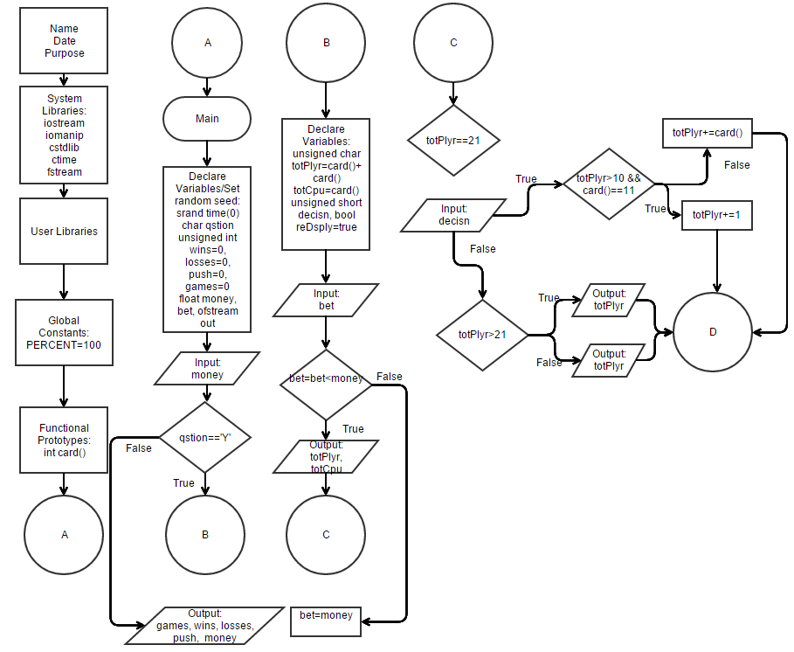

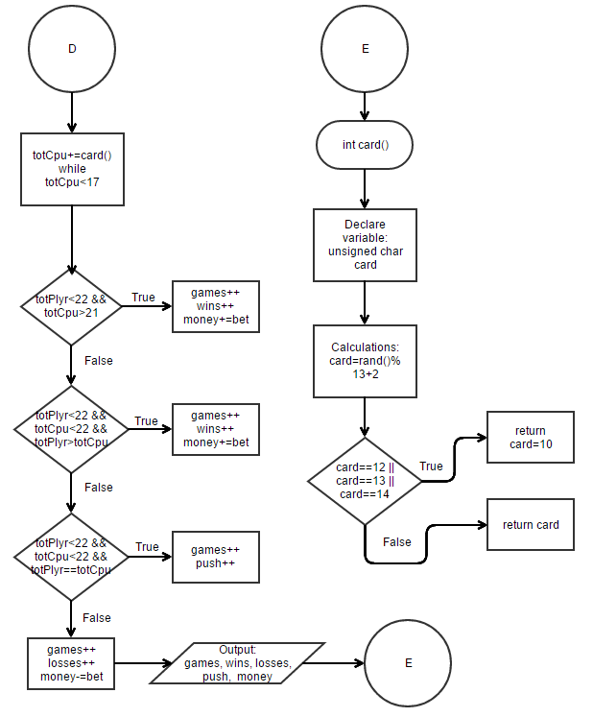

Pseudo code:

//Set the random number seed and declare variables
//Ask if the player wants to keep playing
//Wins, losses, pushes,and games
//How much money the player has total and the bet amount in$
//Setting up the file to be made
//Open a file
//Asking the player for total money
//Declare and initialize variables for playing
//Starting hand for the player
//Starting hand for the computer
//Players input to hit/stand
//Display for hit/stand prompt
//Asking for a bet each time
//Don't let the player bet more than he has
//Setting the bet=money if bet>money
//Adjusting for player getting double aces
//Output the first hand for player and dealer
//Check to see if player has blackjack
//Ask player if he wants to hit or stand
//Playing the hand out, determining wins and losses
//Keep playing?
//Output the information to the screen at the end of playing
//Output the information to a file at the end of playing

/***********************************Card***************************************/
//Declare and initialize variables
//Randomly generating a card to be drawn
//Create a random number
//Random card drawn between [2,14]
//Making sure if it's a Jack, Queen, or King, it converts to a 10

Program:

/*
* File: main.cpp
* Author: Chris Rountree
* Purpose: Blackjack Project V8
* Created on February 1, 2016, 9:37 PM
*/

//System Libraries
#include <iostream> //I/O
#include <iomanip> //Formating
#include <cstdlib> //Srand and rand function
#include <ctime> //Time to set the random number seed
#include <fstream> //File I/O
using namespace std;

//User Libraries

//Global Constants
const char PERCENT=100; //Conversion to percent

//Functional Prototypes
int card();

//Execution Begins Here
int main(int argc, char** argv) {
//Set the random number seed and declare variables
srand(static_cast<unsigned int>(time(0)));
char qstion; //Ask if the player wants to keep playing
unsigned int wins=0,losses=0,games=0,push=0;//Wins, losses, pushes,and games
float money,bet;//How much money the player has total and the bet amount in$
ofstream out; //Setting up the file to be made

//Open a file
out.open("Blackjack.dat");

//Asking the player for total money
cout<<"How much money do you have to gamble with in dollars?"<<endl;
cin>>money;

do{
//Declare and initialize variables for playing
unsigned char totPlyr=card()+card(); //Starting hand for the player
unsigned char totCpu=card(); //Starting hand for the computer
unsigned short decisn; //Players input to hit/stand
bool reDsply=true; //Display for hit/stand prompt

//Asking for a bet each time
cout<<"How much would you like to bet?"<<endl;
cin>>bet;

//Don't let the player bet more than he has
bet=bet<money?bet:money; //Setting the bet=money if bet>money

//Adjusting for player getting double aces
if(totPlyr==22){totPlyr=12;}

//Output the first hand for player and dealer
cout<<endl<<"You have "<<static_cast<int>(totPlyr)<<endl;
cout<<"The dealer has a "
<<static_cast<int>(totCpu)<<" showing"<<endl<<endl;

//Check to see if player has blackjack
if(totPlyr==21){
cout<<"Blackjack! Congratulations, you win!";
games++;
wins++;
money+=bet;
}else
while(totPlyr<22 && reDsply){
//Ask player if he wants to hit or stand
cout<<"What would you like to do?"<<endl;
cout<<"Type 1 to Hit"<<endl;
cout<<"Type 2 to Stand"<<endl;
cin>>decisn;
//Playing the hand out, determining wins and losses
switch(decisn){
case 1:{
if(totPlyr>10 && card()==11){totPlyr+=1;}
else totPlyr+=card();
if(totPlyr>21){
cout<<endl<<"You've busted with "
<<static_cast<int>(totPlyr)<<endl;
games++;
losses++;
money-=bet;
}
else{
cout<<endl<<"You now have "
<<static_cast<int>(totPlyr)<<endl<<endl;
}break;
}
case 2:{
do{
totCpu+=card();
}while(totCpu<17);
cout<<endl<<"The dealer has "
<<static_cast<int>(totCpu)<<endl;
}
default:
if(totPlyr<22 && totCpu>21){
cout<<"Congratulations, you've won!"<<endl;
games++;
wins++;
money+=bet;
}else if(totPlyr<22 && totCpu<22 && totPlyr>totCpu){
cout<<"Congratulations, you've won!"<<endl;
games++;
wins++;
money+=bet;
}else if(totPlyr<22 && totCpu<22 && totPlyr==totCpu){
cout<<"Push."<<endl;
games++;
push++;
}else{
cout<<"Sorry, you've lost."<<endl;
games++;
losses++;
money-=bet;
}reDsply=false;
}
}
//Keep playing?
cout<<endl<<"Do you want to continue you playing, y/n?"<<endl;
cin>>qstion;
cout<<endl;
}while(toupper(qstion)=='Y');

//Output the information to the screen at the end of playing
cout<<"You played "<<games<<" game(s)"<<endl;
cout<<"You won "<<wins<<" game(s), lost "<<losses
<<" game(s), and pushed "<<push<<" game(s)."<<endl;
cout<<fixed<<setprecision(2)<<showpoint;
cout<<"Your win percentage was "<<1.0f*wins/games*PERCENT<<"%"<<endl;
cout<<"You ended with $"<<money<<endl;

//Output the information to a file at the end of playing
out<<"You played "<<games<<" game(s)"<<endl;
out<<"You won "<<wins<<" game(s), lost "<<losses
<<" game(s), and pushed "<<push<<" game(s)."<<endl;
out<<fixed<<setprecision(2)<<showpoint;
out<<"Your win percentage was "<<1.0f*wins/games*PERCENT<<"%"<<endl;
out<<"You ended with $"<<money<<endl;

//Exit stage right
out.close();
return 0;
}

/******************************************************************************/
/***********************************Card***************************************/
/******************************************************************************/
int card(){
//Declare and initialize variables
unsigned char card; //Randomly generating a card to be drawn

//Create a random number
card=rand()%13+2; //Random card drawn between [2,14]

//Making sure if it's a Jack, Queen, or King, it converts to a 10
if(card==12||card==13||card==14){return card=10;}
else return card;
}

